Provenance Visualization on the Web
Software Documentation
Version 1.4
1/29/2013
Document Control
Approval
The Committee members and customers shall approve this document.
Document Change Control
Initial Release: | 12/10/2012
Current Release: | 1/29/2013
Indicator of Last Page in Document:
Date of Last Review: | 1/29/2013
Date of Next Review: | TBA
Target Date for Next Update: | TBA
Distribution List
This following list of people shall receive a copy of this document every time a new version of this document becomes available:
Committee Members:
Dr. Paulo Pinheiro da Silva
Dr. Natalia Villanueva
Dr. Deana Pennington
Change Summary
The following table details changes made between versions of this document

Version | Date | Modifier | Description
0.1 | 12/10/2012 | Hugo Porras | Initial Formatting and Introduction
0.2 | 12/13/2012 | Hugo Porras | Additions to Section 1 and 2
0.3 | 12/16/2012 | Hugo Porras | Added Content to Sections 3,4, and 5
0.4 | 12/17/2012 | Hugo Porras | Added Content to Sections 1, 2, 4, and 5
0.5 | 12/17/2012 | Hugo Porras | Modified Use Case Content in Section 2
0.6 | 12/18/2012 | Hugo Porras | Added References and Figure Numbers
1.0 | 12/18/2012 | Hugo Porras | Revised entire document
1.1 | 12/20/2012 | Hugo Porras | Changes to sections 1.1, 2, and 5 and the addition of the section 6 “Summary”
1.2 | 1/7/2013 | Hugo Porras | Added running time verification results to section 5
1.3 | 1/22/2013 | Hugo Porras | Added new running time results for section 5 and added further analysis
1.4 | 1/29/2013 | Hugo Porras | Revised and edited section 1, 2, and 5. Also added information to section 6

Table of Contents
Document Control ii
Approval ii
Document Change Control ii
Distribution List ii
Change Summary ii
1. Introduction 1
1.1. Introduction 1
1.2. Background Information 1
1.2.1. Provenance 1
1.2.2. Proof Markup Language (PML) 1
1.2.3. Provenance Visualization 2
1.3. Related Work 2
1.3.1. IW-Browser 2
1.3.2. Probe-It 2
1.3.3. VisKo 3
1.4. Purpose and Scope of Project 3
1.4.1. Motivation 3
1.5. Overview 3
2. Software Requirements 5
2.1. Requirements of the Proposed Project 5
2.1.1. Probe-It based Requirements 5
2.1.2. Additional Requirements 5
2.1.3. Query View 6
2.1.4. Product View 7
2.1.5. Local Justification View 8
2.1.6. Global Justification View 9
2.2. Use Case Diagram 10
2.2.1. Actors 10
2.3. Use Case Scenarios 11
2.3.1. Use Case Scenario 1: Analyze Provenance Graph 11
2.3.2. Use Case Scenario 2: Retrieve Query Answers 11
2.3.3. Use Case Scenario 3: Inspect Conclusion Visualizations 12
2.3.4. Use Case Scenario 4: Analyze Node-Set Details 13
3. Software Design 14
3.1. Overlaying Architecture 14
3.2. Design Description 14
3.2.1. Client-Side Web-Probe User Interface 14
3.2.2. Direct Web Remoting (DWR) Connection 15
3.2.3. PML Interfaces 15
3.2.4. Visualization Cache Sub-System 16
4. Implementation 17
4.1. Description of Implementation 17
4.1.1. Client-Side 17
4.1.2. Direct Web Remoting (DWR) 17
4.1.3. Server-Side 17
4.2. Maintenance 18
4.2.1. Web-Probe Setup 18
4.2.2. Repository 19
5. Validation & Verification 20
5.1. Validation 20
5.2. Verification 20
5.2.1. Replicated Probe-It Functionality 20
5.2.2. Additional Requirements 23
5.2.3. Web-Probe vs. Probe-It Running Times 24
6. Summary 31
6.1. Conclusion 31
6.2. Future Work 31
6.3. Issues List 31
7. References 32

Introduction

Introduction
In complex virtual environments like cyber-infrastructures, scientists rely on visualization tools to help them understand large amounts of data that are generated from experiments, measurements obtained by sensors, or a combination of measurements and applied derivations. Instead of tediously tracing through datasets, scientists view results as visualizations (i.e. as condensed graphs, maps, etc) and draw conclusions from these projected views. However, in order for scientists to fully understand and accept artifacts generated on the cyber-infrastructure, scientists may need to know which data sources and data processing services were used to derive the results and which intermediate datasets were produced during the derivation process. The collection and visualization of this provenance information plays a key role in enabling scientists to perform these tasks.
Visualization is a technique used to facilitate the understanding of scientific results such as large data sets and maps. Provenance techniques can also aid in increasing the understanding and acceptance of scientific results by providing access to information about the sources and methods which were used to derive them. Visualization and provenance techniques may further increase scientists' understanding of results since the scientists may be able to use a single tool to see and evaluate result derivation processes including any final or partial results.
This document presents the web-application, Web-Probe, that was created to enable scientists to browse and analyze provenance in a visually enhanced manner on the web. The projects overall goals are to replicate the functionality of the previous tool Probe-It [7], including all the main provenance browsing views Probe-It provides (Query View, Product View, Local Justification View, Global Justification View). Web-Probe would also ensure the use of the Visualization Caching System, which Probe-It also uses. In addition to these requirements, Web-Probe will also provide the ease of rapidly accessing the application and the provenance visualizations on the web through a web browser. This document presents the background, motivation, software requirements, software design, implementation, and validation and verification of the Web-Probe provenance visualization tool.

Background Information

Provenance
Provenance is described as meta-information about the final results and how they were generated. Provenance information includes: provenance meta-information, which is a description of the origin of a piece of knowledge (e.g., names of organizations, people, and software agents who played some role in the generation of an artifact), process meta-information, which is a description of the reasoning process used to generate an answer, such as a proof or execution trace, and intermediate or partial results. Provenance often includes meta-information about the following: original datasets used to derive results; executions of processes, i.e., traces of workflow executions and composite services execution; methods called by workflows and composite services, i.e., services, tools, and applications; intermediate datasets generated during process executions; and any other information sources used.

Proof Markup Language (PML)
Provenance browsed by Web-Probe is encoded in the Proof Markup Language (PML) [1, 2] provided by the Inference Web [3, 4]. Inference Web leverages PML for encoding and publishing provenance information on the web as well as providing a set of tools and services for handling these documents. PML is an OWL [5] based language that can be used for encoding provenance. PML consists of a specification of terms for encoding collections of justifications for computationally derived results. Depending upon the application domain, users may view each justification as an informal execution trace or as a proof describing the inference steps used by an inference engine, e.g., a theorem prover or web service, to derive some conclusion. From this perspective, PML node sets (i.e., the topmost element in the language) represent the invocation of some service; the node set conclusion serves as the output of the service while the inference step represents the provenance meta-information associated with the function provided by a service or application. For example, the inference step proof elements antecedent, rule, and inference engine can be used to describe the applications inputs, function, and name respectively.

Provenance Visualization
Visualization is a technique used to facilitate the understanding of scientific results such as large data sets and maps. Provenance techniques can also aid in increasing the understanding and acceptance of scientific results by providing access to information about the sources and methods which were used to derive them.
Provenance can become large and effectively presenting it to scientists can become challenging. One method to improve the presentation of provenance may employ visualizations and render this information graphically, which we refer to as provenance visualization. Indeed, visualization and provenance dissemination techniques, although rarely used in conjunction, may further increase scientists' understanding of results and thus provide superior support for assessing the quality of complex results. We define provenance visualization as a framework suitable for visualizing both a complex result and its associated provenance. Provenance visualization is focused around the challenge of combining provenance and visualization techniques so that scientists can have a single interaction and navigation model to understand results, by inspecting how they are derived. We see the visualization of process meta-information, i.e., execution traces, as one of the key components for provenance visualization. If scientists can understand how results were derived, then they may have an increased chance of accurately assessing the quality of the result.

Related Work

IW-Browser
IW-Browser (Inference Web - Browser) [6] is a graphical rendering tool for PML proofs. The Inference Web Browser focuses on rendering PML with conclusions based on logical statements derived from a theorem prover or intelligent agents. In cyber-infrastructure based conclusions and results, the data can encompass a range of visualizations, and thus extra features were desired to exploit these aspects. Probe-It was born from these needs.

Probe-It
Probe-It [7] is a Java based Provenance Visualization browser, from which Web-Probe is meant to replicate on the web. Probe-It is a graphical provenance (PML) browser suited to helping scientists identify and explain scientific results. Probe-It is a visualization tool for scientific provenance information that enables scientists to move the visualization focus from intermediate and final results to provenance back and forth. Probe-It is able to visualize PML provenance associated with results of inference engines and workflows. Probe-It does not actually generate content (i.e. logging or capturing provenance information); it is assumed that users provide Probe-It with end-points of existing PML documents. Because PML graphs and provenance in general can become large and incomprehensible as a whole, Probe-It consists of a multitude of viewers, each suited to different elements of provenance. This effectively decomposes provenance into smaller more comprehensible chunks.

VisKo
The Visualization Knowledge (VisKo) [8] project is a framework supporting the answering of visualization queries that allow users to specify what visualizations they want generated rather than specifying how they should be generated. In this project VisKo is used as a service to provide scientific visualizations for resulting data at all levels of a provenance trace.

Purpose and Scope of Project

Motivation
The motivation for this project is largely based on the needs for improvement in its predecessor Probe-It. Newer technologies and overall better support for web-based development pushed the Probe-It team to consider a web-application version of the tool. The emergence of web visualization libraries such as Data Driven Documents (D3.js)[9] not only made moving to a web-based system feasible, but made it desirable for the possibility of eventually making Probe-It visualization techniques more accessible, faster, and overall more interactive.

Improvements for Probe-It
Probe-It was built to provide functionality that presented both provenance and scientific visualization capabilities that IW-Browser did not offer, however, it lacked the accessibility that the web provided and additional flaws that needed to be addressed. First of all, it required users to download and install the application. This required users to install Java Run-time, if they did not already have this installed. Once installed and running, the tool required resources from the web to load PML. The Java Webstart environment (which was used to easily install Probe-It) would require the user to accept permissions to external resources it requested. This could come to be an annoyance for users, and even a point for new users to be concerned of whether they should trust the tool enough to allow access to these external resources. In the end the tool required several steps to setup and several decisions on the user’s part to even begin to visualize and browse the data, and that is if they decided to trust the tool to connect to external software. In addition, the tool’s loading times of proofs and conclusions also posed a problem. This process could take several minutes to load on larger provenance traces. This was due to the required generation and manipulation of scientific visualizations. As a result, the analysis of a dataset’s provenance could take a very long time.

Project Objective
For the reasons stated above, a new web-application (Web-Probe) that could support the visualization capabilities of Probe-It was needed. Web-Probe [10] would also require an efficient method of displaying scientific visualizations to the user (One that would make use of pre-generated visualizations associated with the provenance data). The web-application would only require users to have a web-browser with java-script support in order to quickly begin browsing provenance on the web. Web-Probe would support all the main views of the Probe-It system and show the same information and visualizations it provided. The main objective of the project would be to provide the core functionality of Probe-It, while also providing improvements in loading times, and provide a stepping stone for further improvements in the development of provenance visualization.

Overview
The following sections of the document will describe:
  - Requirements of the System
  - Use Case Diagram
  - Software Design
  - Implementation
  - Validation and Verification
  - Summary
  - References

Software Requirements

Requirements of the Proposed Project
The proposed provenance visualization web application was meant to provide users with the same capabilities that Probe-It offered, but with the additional functionality that the application can be easily accessible through the web. The system is started by a user or software by visiting the web-applications root URL. From here the user can begin browsing provenance by providing a URI for a desired provenance endpoint, or choose from a list of examples. The URI can also be passed through as a URL parameter. This enables software tools that capture provenance to provide links to their users and visualize provenance using Web-Probe.

The web application has several outside resources. The Visualization Cache Sub-System [11] employs the RDF Store Services [12] to generate a list of all known possible provenance Node-Sets, and then uses this list to generate possible visualizations associated with the provenance by invoking VisKo services. The system also uses the PML API to access information from PML documents. The final resource is D3.js, which is a Java-Script data driven visualization library.

Probe-It based Requirements
The tool will give users the same views that Probe-It provided, listed below (greater detail is provided in the subsections below [2.1.3 - 2.1.6]):
- Query View
- Product View
- Local Justification View
- Global Justification View

Additional Requirements
In addition, the system will also offer the following:
- The application should not require users to install secondary software, besides an up to date browser that supports java-script.
- Pre-rendered visualizations in order to improve provenance browsing speeds.
- Faster application startup times
- Faster provenance trace loading times

Query View
The Query View is composed of a query section and the corresponding answers section. The query section displays the formal representation of a user’s question, and any natural language versions of the user’s question, if available. The answers section displays all corresponding answers to the query that was asked. The answers can be selected to begin inspection of the provenance trace (This is started by generating the provenance trace graph in the Global Justification View).

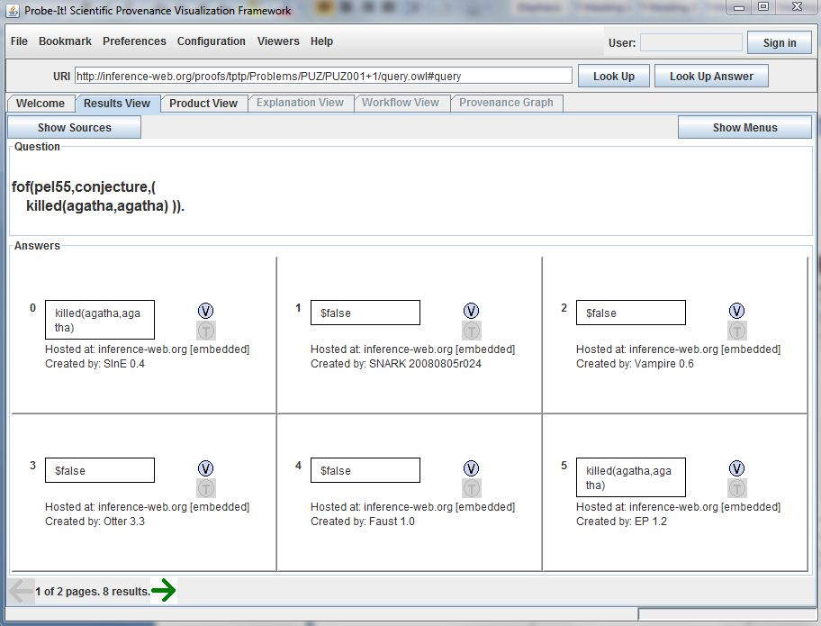
Figure 1: Probe-It Query View

Product View
The Product View is used to display and cycle through all the different forms of visualizing a Node-Set conclusion. The View must be capable of displaying the different formats of visualizations that are generated by the VisKo services.

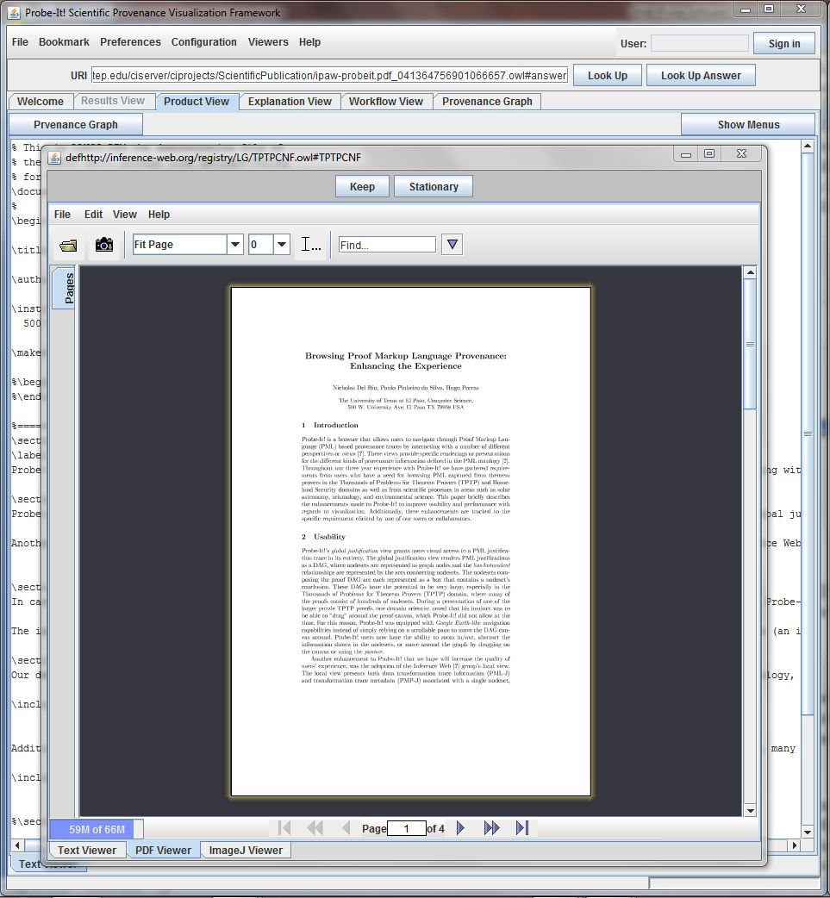
Figure 2: Probe-It Product View

Local Justification View
The Local Justification View must display provenance and justification information about a NodeSet. The Local Justification View is also used to navigate through the provenance trace by clicking on links to other NodeSets associated with the current one.

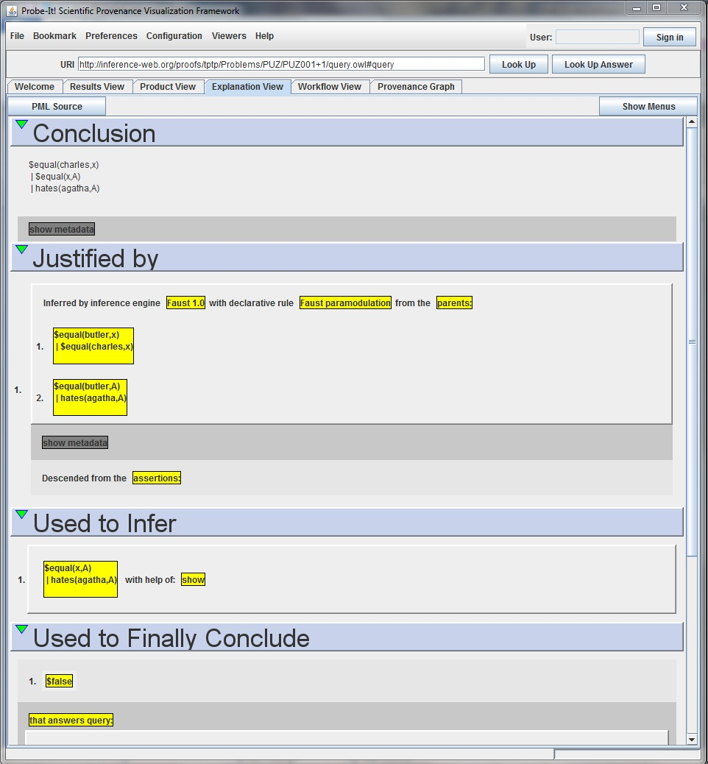
Figure 3: Probe-It Local Justification View (Explanation View)

Global Justification View
The Global Justification View displays the provenance trace in an interactive and graphical form. Node-Sets are displayed as nodes in a graph, and links to other Node-Sets are displayed as line connections. Further details of the Node-Set can be viewed by selecting the node. This will allow the user to view the Product View and the Local Justification View for the selected Node-Set. Probe-It currently supports several styles of displaying the graph, but initially only the Tree style is required. The graph can also be moved by a panning action and must have zooming capabilities.

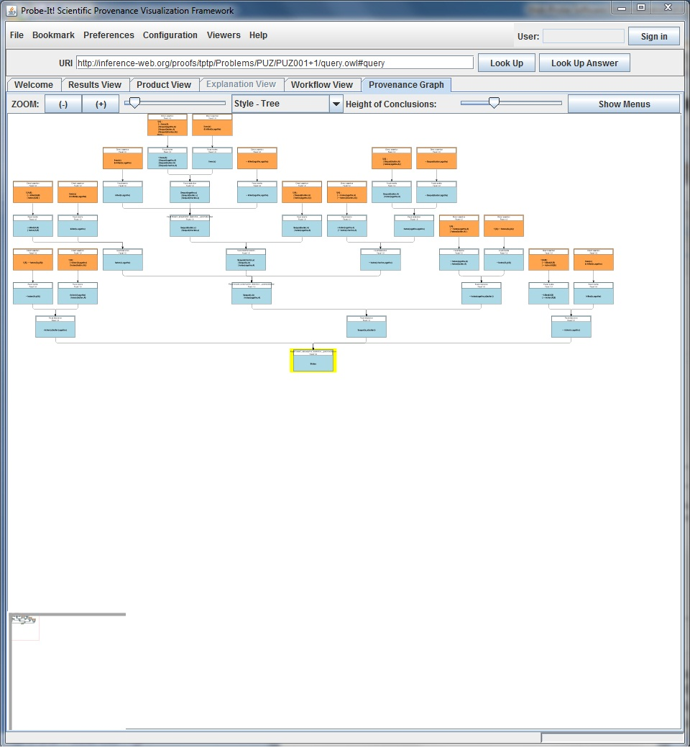
Figure 4: Probe-It Global Justification View (Provenance Graph)

Use Case Diagram
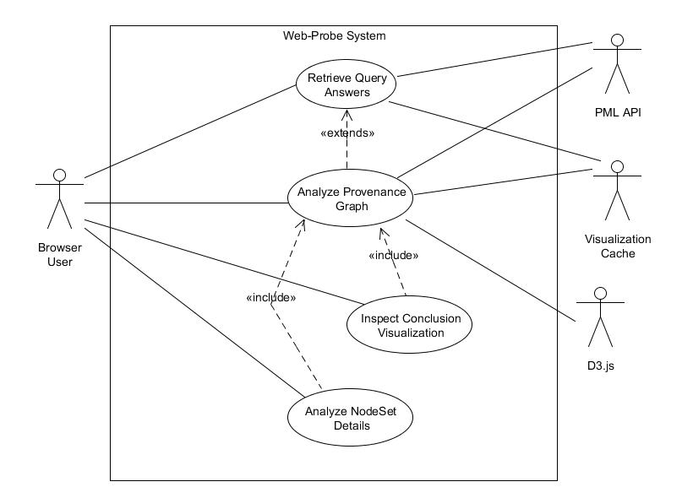
Figure 5: Use Case Diagram

Actors
The descriptions below are the actors that interact with the Web-Probe System. There is the Browser User, D3.js, PML API, and Visualization Cache

Browser Users
The browser user is the actor that interacts with the system through the Web-Probe web-browser user interface. This actor will be requesting information from URI endpoints through the user interface. The user will interact with the user interface analyze information and make requests to the other actors.

D3.js
The D3.js (Data Driven Documents) actor is going to be generating the provenance graph visualizations. This actor uses the provenance justification tree that is constructed through the use of the PML API to produce an interactive graph.

PML API
The PML API actor takes requests from the system to read PML documents and returns the desired information. The PML API has complete knowledge of the structure of PML documents and provides services to the system to retrieve specified pieces of information.

Visualization Cache
The Visualization Cache actor provides full sized visualizations and thumbnails for the system to display. It interacts with both the VisKo and RDF-Store services to produce these visualizations.

Use Case Scenarios

Use Case Scenario 1: Analyze Provenance Graph

Actors: Browser User, Visualization Cache, PML API, D3.js
Summary: The user wants to view a graph of the justification trace of a PML Node-Set
Precondition: System is idle at the home screen.
Post-condition Success: User receives information requested.
Post-condition Failure: User does not receive information requested, instead receives an error message.
- The application is loaded at the home screen.
- The Browser User enters a Node-Set URI and selects Lookup.
- The system displays a loading screen while it retrieves information from the PML API and Visualization Cache, and displays the provenance graph when ready. (ALT1)
- The user clicks a node of the graph to view more information
- The system shows the node as selected and displays more information about the node.
The user engages in analyzing the provenance information it displays.
- The user finishes analyzing and closes the application. (ALT2)
- End of Use Case

ALT 1: URI is incorrect or can’t be loaded.
A1-1. System displays that there was a problem loading the URI endpoint and the user should make sure the URI was entered correctly.
A1-2. End use case.

ALT 2: The user wants to continue analyzing the graph.
A2-1. The user selects a different node of the graph to view more information
A2-2. Continue to step 5 in the main flow.

Use Case Scenario 2: Retrieve Query Answers

Actors: Browser User, Visualization Cache, PML API
Summary: The user wants to view a PML Query’s details along with the corresponding answers. The
user may want to select an answer which will then start Scenario 1.
Precondition: System is idle at the home screen.
Post-condition Success: User receives information requested.
Post-condition Failure: User does not receive information requested, instead receives an error
message.
- The application is loaded at the home screen.
- The Browser User enters a Query URI and selects Lookup.
- The system displays a loading screen while it retrieves information from the PML API and Visualization Cache, and displays the Query/Question and the answers associated with the Query. (ALT1)
- The user inspects the Query/Question text and answer results.
- The user finishes and closes the application (ALT2)
- End of Use Case

ALT 1: URI is incorrect or can’t be loaded.
A1-1. System displays that there was a problem loading the URI endpoint and the user should make sure the URI was entered correctly.
A1-2. End use case.

ALT 2: The user wants to analyze the provenance graph of one of the results.
A2-1. The user selects an answer he/she wishes to inspect further
A2-2. Ext:: Continue to step 3 in the main flow of Use Case Scenario 1.

Use Case Scenario 3: Inspect Conclusion Visualizations
Actors: Browser User
Summary: The user wants to view a Node-Set Conclusion’s corresponding Visualizations.
Precondition: The system is displaying a provenance graph.
Post-condition Success: User receives information requested.
Post-condition Failure: User does not receive information requested, instead receives an error message.
- Include:: Use Case Scenario 1.
- The application is displaying the provenance graph.
- The Browser User selects a node for detailed inspection of visualizations.
- The system displays a loading screen while it retrieves and displays the information. The system displays the first visualization when it is ready, along with options to view other alternate visualizations. (ALT1)
- The user engages in analyzing the visualization.
- The user finishes analyzing and closes the application. (ALT2)
- End of Use Case

ALT 1: Information cannot be displayed.
A1-1. System displays that there was a problem loading and displaying the information requested, and to try again later.
A1-2. End use case.

ALT 2: The user wants to analyze another available visualization.
A2-1. The user selects a different visualization from the options.
A2-2. The system displays the visualization selected, and updates the selection.
A2-3. Continue to step 5 in the main flow.

Use Case Scenario 4: Analyze Node-Set Details
Actors: Browser User
Summary: The user wants to view a detailed description of a Node-Set, including Conclusion, justification, inference step, inference usage, and final conclusion.
Precondition: The system is displaying a provenance graph.
Post-condition Success: User receives information requested.
Post-condition Failure: User does not receive information requested, instead receives an error message.
- Include:: Use Case Scenario 1.
- The application is displaying the provenance graph.
- The Browser User selects a node for detailed inspection of provenance information.
- The system displays a loading screen while it retrieves and displays the information. The system displays the Node-Set provenance information once it is ready. (ALT1)
- The user engages in analyzing the provenance information.
- The user finishes analyzing and closes the application. (ALT2)
- End of Use Case

ALT 1: Information cannot be displayed.
A1-1. System displays that there was a problem loading and displaying the information requested, and to try again later.
A1-2. End use case.

ALT 2: The user wants to analyze another Node-Set.
A2-1. The user selects a link to another Node-Set from the provenance information displayed.
A2-2. Continue to step 4 in the main flow.

Software Design

This section contains a description of the high-level design decisions taken in order to build the provenance visualization system. It contains a collaboration diagram to visually show the structure of the overall architecture and follows up with a description of responsibilities for each sub-component.

Overlaying Architecture
The purpose of the following diagram is to help give an overall view of the architecture of the provenance visualization system.

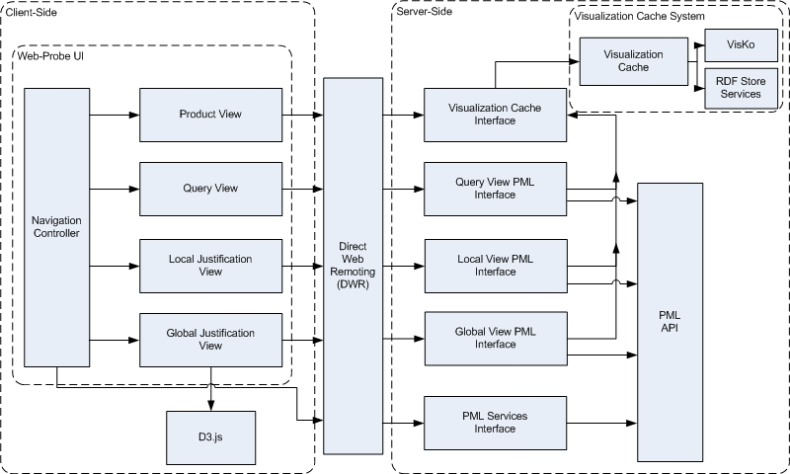

Figure 6: Overlaying Architecture

Design Description
The overall design is made up of two main components. The client-side is in charge of interacting with user input and displaying provenance information through four main views. The server-side component is in charge of two main responsibilities: Accessing cached visualizations that have been pre-generated, and retrieving provenance information (in this case PML encoded provenance) for the particular views that are requesting the information. The two components are connected via DWR, for Java-Script to Java communication.

Client-Side Web-Probe User Interface
The Web-Probe User Interface is designed to handle the delegation of user input and actions, along with the display of user interface menus and provenance information. The system is designed to delegate the more intensive computations related to the gathering of PML information and scientific visualizations to the Server-Side components.

Navigation Controller
The Navigation Controller is in charge of listening to user input that requires new provenance information to be loaded for any particular view. Essentially, The Navigation Controller detects user input that will cause a server call to be made. It has knowledge of what actions cause a particular View or Views to change, and dispatches the appropriate View builder to begin information retrieval and display for the particular View at hand.

Product View
The Product View is in charge of displaying all possible visualizations for a particular Node-Set conclusion. It contains the knowledge of how to display the different visualizations that are returned from the Visualization Cache, which are called Viewers of each type/format of visualization. The different visualizations can be cycled through by the use of tabs. The Product View is the only View that directly invokes the Visualization Cache Interface, since its only role is to display this information, whereas all the other Views call the Visualization Cache indirectly through their designated PML interfaces.

Query View
The Query View is in charge of retrieving and displaying provenance queries and the corresponding answer results. The answers can than be selected for further inspection. This View requires a URI of a Query in order to fetch the information using its PML Interface.

Local Justification View
The Local Justification View is in charge of displaying all the provenance information associated with a particular Node-Set conclusion. It displays information having to do with the result of the particular Nodes-Set, what was used to arrive at the particular conclusion, how this conclusion is used for to further create other conclusions, and what the overall conclusion provenance trace is. The PML information is retrieved from the View’s PML Interface. This is all displayed in organized sections and can be used to navigate through the entire provenance trace from one Node-Set conclusion to another, using links to the other Node-Set conclusions.

Global Justification View
The Global Justification View is in charge of displaying the entire provenance trace graphically. This can include different graphical modes of provenance visualization. This View is in charge of displaying the graph returned by its PML Interface using the D3.js library, and interactions made by the user to adjust the provenance visualization; Including, but not limited to, displaying conclusion viewers of a particular Node-Set conclusion (in which case an embedded smaller version of the Product View is used), zooming, panning, etc.

Direct Web Remoting (DWR) Connection
Direct Web Remoting is the software used to manage and carry out the connection between the client-side and server-side components. This component is required to carry out asynchronous communication between the Java-Script client-side and Java based server-side.

PML Interfaces
All PML Interfaces are in charge of gathering PML provenance information for a given URI, associated with the particular View, and returning that information in a format that can be decoded by the Client-Side components (JSON). PML data is decoded using the PML API. The PML Interfaces are designed to compile all the information needed for a particular URI, requiring only one invocation per URI desired to be inspected in order to minimize the frequency of communication between the Client-Side and Server-Side.

Query View PML Interface
The Query View PML Interface is in charge of collecting PML data associated with a PML Query using the PML API. This along with any image visualizations is gathered and returned to the Client-Side component using the DWR communication and the JSON format for Client-Side use.

Local View PML Interface
The Local View PML Interface is in charge of collecting PML data associated with a PML Node-Set Conclusion identified by a URI. The URI is used to access information about the Node-Set’s conclusion, antecedents, derived conclusions, inference engines, etc., using the PML API. This along with all image visualizations for all conclusions associated with the provenance of the particular Node-Set conclusion are gathered and returned to the Client-Side component using the DWR communication and the JSON format for Client-Side use.

Global View PML Interface
Similarly, the Global View PML Interface is in charge of collecting PML data associated with the whole PML provenance trace, identified by the root Node-Set Conclusion URI. The URI is used to generate the provenance trace graph, using the PML API. This along with all image visualizations for all conclusions in the whole provenance trace are gathered and returned to the Client-Side component using the DWR communication and the JSON format for Client-Side use.

PML Services Interface
The PML Services Interface is designated for small PML inquiries. The main purpose is to do minor and relatively quick checks (when compare to the other PML interfaces) for validating whether URI’s point to valid PML endpoints, and whether they pertain to PML Queries or Node-Sets.\

Visualization Cache Sub-System
The Visualization Cache is a subsystem of its own. The subsystem is in charge of managing pre-generated Node-Set Conclusion visualizations and finding previously un-cached visualizations of all known Node-Set Conclusions. This is done by using RDF Store Services [*] to find all known Node-Set Conclusion URI’s, then generate the subset of Conclusion visualizations that are not cached using VisKo [*] services to generate the visualizations, and finally storing the information of the visualizations for later use.

Implementation

Description of Implementation

The system’s overall implementation follows the high level design explained above in Section 5. The implementation aspects are best described by separating the Client-Side from the Server-Side and the communication management performed in-between.

Client-Side
The Client-Side is implemented using a combination of HTML, Java-Script, and CSS. There is a main html file that, along with its according CSS file, handles the overall organization and look and feel of the application. This main HTML file includes all the Java-Script and CSS files that are used for the application (including external libraries). The Java-Script and CSS is organized according to the View it pertains to. The navigation logic is also separated into its own organized set of Java-Script files.

Several external libraries are also included. D3.js, JQuery [13], JQuery-UI [14], and JSON [15] utilities are among the external libraries required. D3.js is used for the visualization of provenance graphs in the Global Justification View. JQuery is a library used for the manipulation of HTML DOM (Document Object Model) components. JQuery improves Java-Script code readability, as well as easing the addition of outside plug-ins. Plug-ins using JQuery were used to facilitate the generation of loading screens[16] and tooltips[17]. JQuery-UI was also used to help keep an overall look and feel throughout User Interface widgets. JSON utilities were used to validate and generate JSON objects from returned values from Server-Side components.

Direct Web Remoting (DWR)
Direct Web Remoting [18] is a Java to Java-Script (and vise versa) asynchronous communication framework. In this implementation it particularly simplifies the Java-Script invocation of Java services located on a server. This was crucial to the development of the web-application due to the PML API being available only in the Java language. One of the main concerns of this project was how to connect a Java-Script based application to a Java backend. This was the only real solution that was found for the project. The framework generates Java-Script objects that pertain to any Java classes defined in an XML document called dwr.xml (found under the WEB-INF folder). The objects generated contain the logic of what classes to call using DWR libraries.

Server-Side
The Server-Side takes advantage of the Object-Oriented Language of Java. The server-Side is completely implemented in Java. This decision was taken because it was necessary in order to interface with the PML API, and also to take advantage of Object-Oriented Language aspects, such as increased organization, reusability, readability.

All of the Interfaces (designed to be client-side interfaces), are designed to hold Java objects that all have their according JSON converters. JSON is the Java-Script Object Notation and is widely supported across most popular languages (a list can be found on the JSON website [15]). This makes the returning of Java-Script usable objects easy. The Java classes can all store the information in the Java data types, and once all the information has been gathered a simple call to the JSON converter method for the object is called and returns a JSON String representation of the Java object. This is then sent back to the Client-Side for each View’s use.

Maintenance
This section describes how Web-Probe is configured, and how it can be setup on other servers. Also described is the repository location of the source code, from which anyone can view the source code and has access to expand or modify the project.

Web-Probe Setup
Web-Probe can be Setup on any server. The main setup can be found at http://iw.cs.utep.edu/Web-Probe/. The following steps describe how to setup Web-Probe on a Linux server, and is how the application is currently setup on the UTEP Cyber-Share server IW (these instructions can also be accessed here: https://github.com/hdporras/Web-Probe/wiki/Installing-Web-Probe ).

Web-Probe Installation Pre-requisites:
- Java Runtime Environment
- Apache Tomcat
- Apache Ant

Apache Tomcat Installation
Download latest Apache Tomcat (http://tomcat.apache.org/)

- Tomcat 7 (Binary Core)
- Extract contents into a desired directory on file system
- Go to the bin folder under the tomcat installation
- Run startup.sh/startup.bat (This will startup the tomcat server listening on port :8080)
- Test if this has worked by opening your browser and typing url localhost:8080
- If there is something else listening on port :8080 you can modify what port tomcat listens to by editing the server.xml file tomcat-installation/conf/server.xml
- Change the "Connector port="8080"" settings and restart tomcat.
- Once you verify that localhost:8080 is running, tomcat is good to go.

Apache Ant
- Download latest Apache Ant (http://ant.apache.org/)
- For instructions on installing apache ant follow the installation instructions from the manual: http://ant.apache.org/manual/index.html

Web-Probe Installation

Cloning Git Repository
To begin the installation of the Web-Probe Application, first we must clone the source code from the github repository.

- Create a new directory for the source code to live in.
- Navigate to the new directory and run the following: “git clone https://github.com/hdporras/Web-Probe.git”

You should now have all the source code for Web-Probe under your newly created directory.

Creating WAR file
Now that you have the code, you need to compile the Web-Probe source code into a WAR file (Web application ARchive file). The WAR file is used to upload the web application to the Tomcat Server. We will use Apache Ant to compile and generate the WAR file.

Ant Build
To generate the WAR file you will use the build.xml file that comes with the source code from git:

- Navigate to the cloned git code on your local machine.
- Under the Web-Probe directory invoke ant with the target “build” by typing the following in your command line :

“ant build”

When the ant build is finished the Web-Probe.war will be generated within the same directory.

Deploying to Tomcat
To deploy Web-Probe on your Tomcat server, simply copy and paste the Web-Probe.war file into your-Tomcat-Installation/webapps/ folder. If tomcat is on, it will unpackage and deploy Web-Probe. Give it a moment to do this and then Web-Probe should be deployed to localhost:8080/Web-Probe/

Web-Probe Installation Finished.

Repository
Web-Probe’s implementation is stored on the GIT-based [19] social coding site of Git-Hub [20]. The code is available at the following git endpoint: https://github.com/hdporras/Web-Probe.git. This can be used to fork, clone, or commit changes to the repository. One can browse the repository by visiting the following location https://github.com/hdporras/Web-Probe. From here anyone can browse the code and see changes that have been made to the repository.

Validation & Verification

Validation
The approach taken to validate this project was to ensure that all the core functionality that was provided by Probe-It (described in Section 2 “Software Requirements”) was replicated in the new web-application Web-Probe.

Verification
Verification of the project was performed by ensuring that the functionality that both Probe-It and Web-Probe provide for the core components are the same. Also, See Section 2 “Software Requirements” for more details of what functionality was required of Web-Probe.

Replicated Probe-It Functionality
The tool had to exhibit the following described requirements for it to completely fulfill the required functionality that was put forth in Section 2. In the following subsections we present, for each feature, images and a description of what had to be fulfilled to pass the verification process.
The following table shows the list of functionality that was fulfilled by either tool, and was used to ensure that Web-Probe was providing the same functionality that Probe-It provided.

Feature | Probe-It | Web-Probe
Query View | √ | √
Product View | √ | √
Local Justification View | √ | √
Global Justification View | √ | √
Visualization Cache Connection | √ | √
Accessible using only a Java-Script enabled Web Browser |  | √
Figure 7: Verification Checklist

Query View
The Query View is composed of a query section and the corresponding answers section. The query section displays the formal representation of a user’s question, and any natural language versions of the user’s question, if available. The answers section displays all corresponding answers to the query that was asked. The answers can be selected to begin inspection of the provenance trace (This is started by generating the provenance trace graph in the Global Justification View). Below is a comparison of Web-Probe and Probe-It (Figure 8), which was done to verify that Web-Probe correctly replicated the functionality.

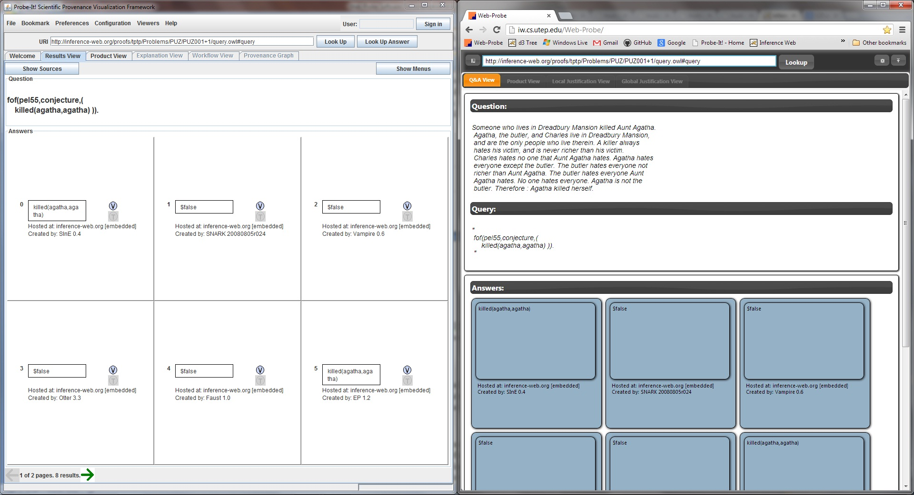
Figure 8: Comparison of Probe-It (left) and Web-Probe (right) Query Views

Product View
The Product View is used to display and cycle through all the different forms of visualizing a Node-Set Conclusion. The View must be capable of displaying the different formats of visualizations that are generated by the VisKo services. Below is a comparison of Web-Probe and Probe-It (Figure 9), which was done to verify that Web-Probe correctly replicated the functionality.

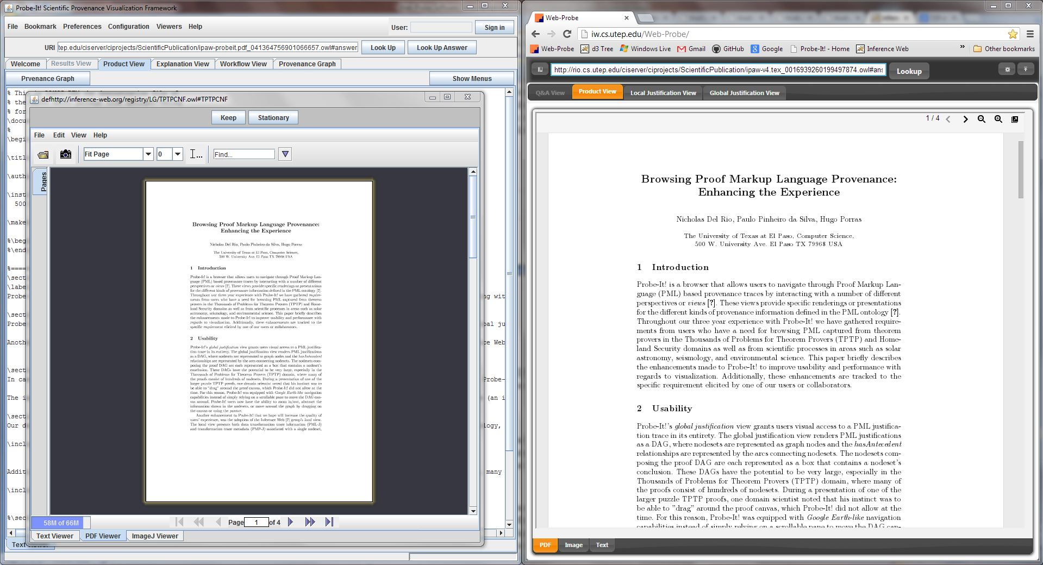
Figure 9: Comparison of Probe-It (left) and Web-Probe (right) Product Views

Local Justification View
The Local Justification View must display provenance and justification information about a NodeSet. The Local Justification View is also used to navigate through the provenance trace by clicking on links to other NodeSets associated with the current one. Below is a comparison of Web-Probe and Probe-It (Figure 10), which was done to verify that Web-Probe correctly replicated the functionality.

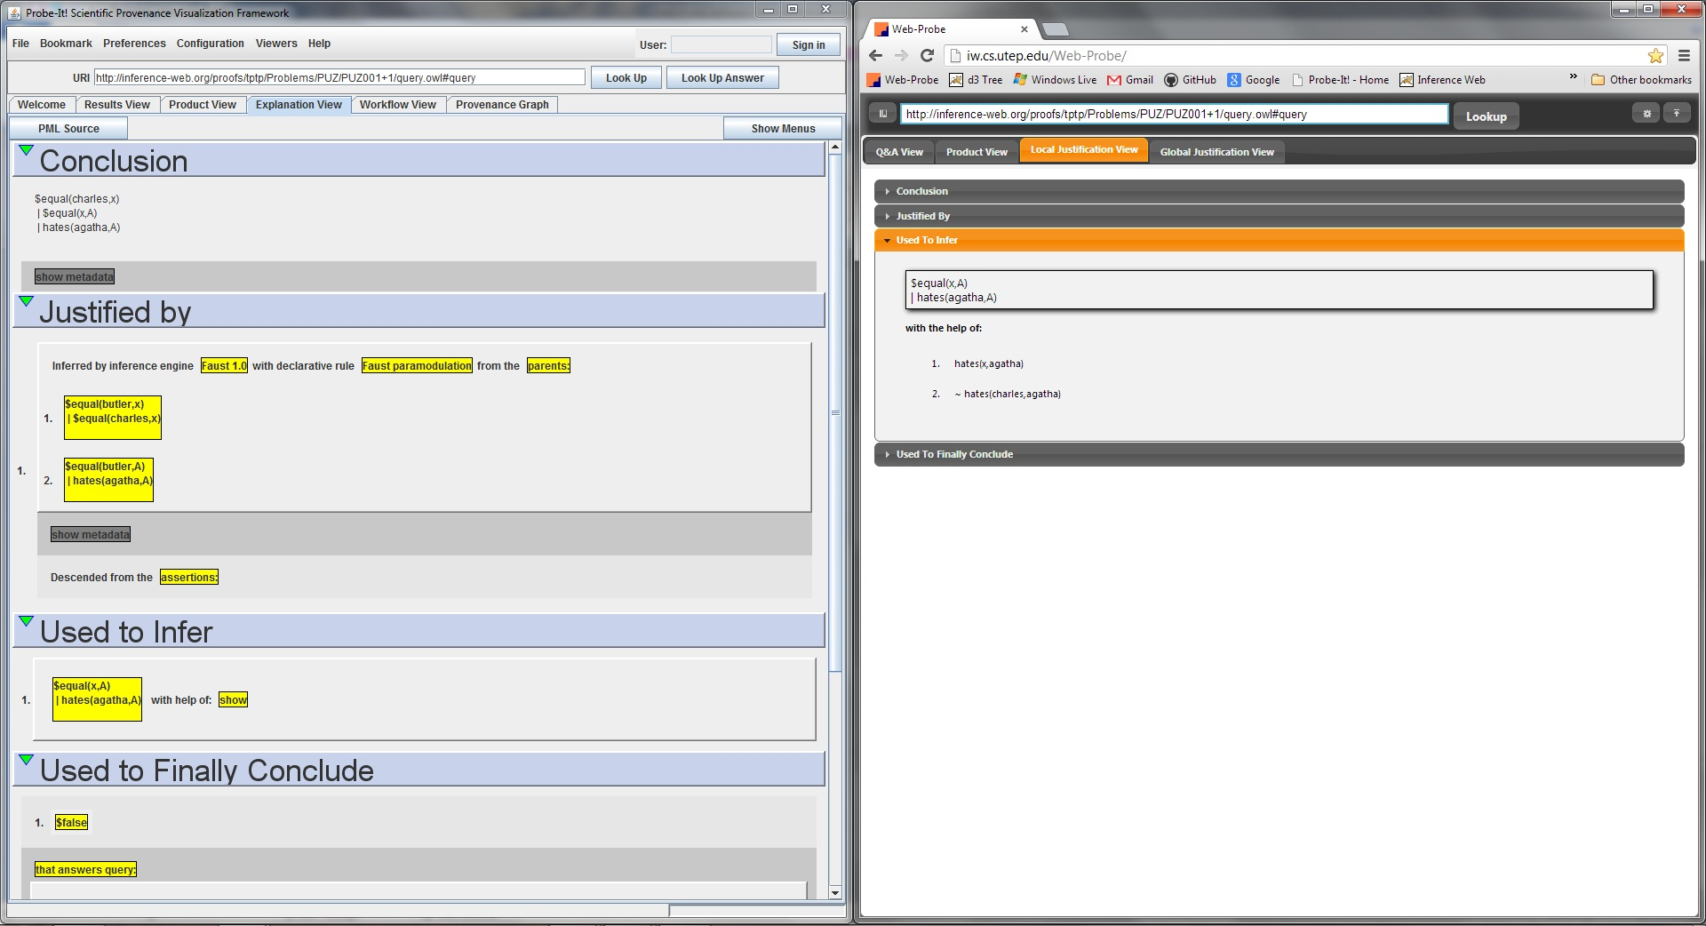
Figure 10: Comparison of Probe-It (left) and Web-Probe (right) Local Justification Views

Global Justification View
The Global Justification View displays the provenance trace in an interactive and graphical form. Node-Sets are displayed as nodes in a graph, and links to other Node-Sets are displayed as line connections. Further details of the Node-Set can be viewed by selecting the node. This allows the user to view the Product View and the Local Justification View for the selected Node-Set. The graph can also be moved by a panning action and must have zooming capabilities. Below is a comparison of Web-Probe and Probe-It (Figure 11), which was done to verify that Web-Probe correctly replicated the functionality.
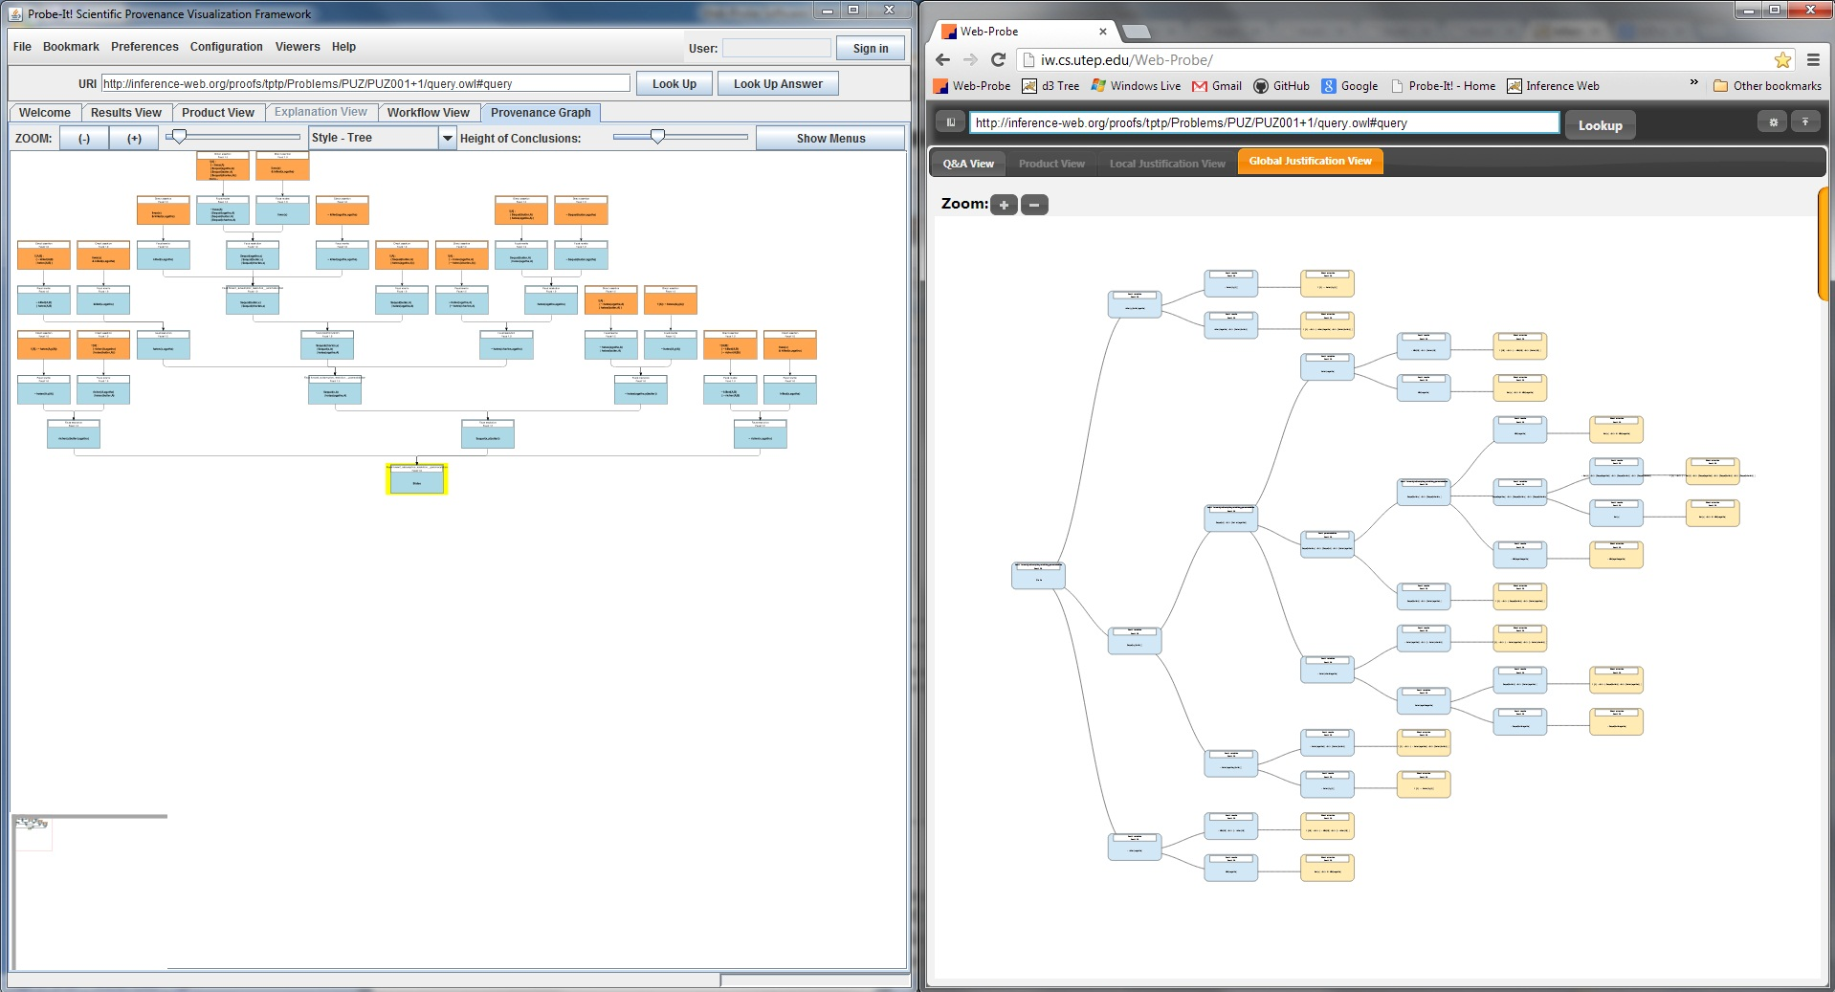
Figure 11: Comparison of Probe-It (left) and Web-Probe (right) Global Justification Views

Additional Requirements

Accessible through Web Browser
The application was made available through the Web by hosting the application at the IW server in the Cyber-ShARE Center at UTEP. The location of the application is accessible through JavaScript enabled browsers like Chrome, Firefox, Internet Explorer, etc. Example using Google Chrome shown below (Figure 12).

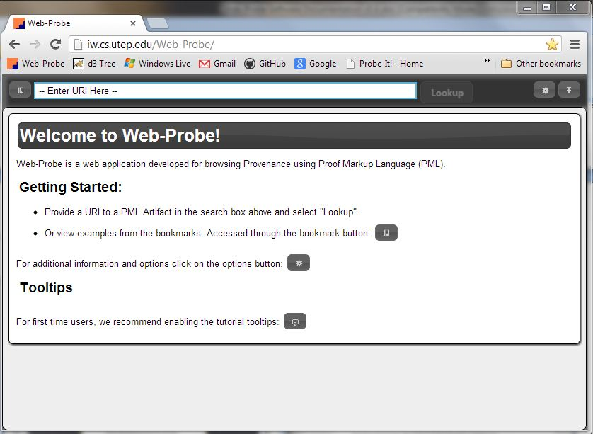
Figure 12: Web-Probe Start Display

Connection to Visualization Cache
Web-Probe’s Visualization Cache connection is the only component the application has to connect to scientific visualizations for intermediate results. Verification of this requirement was made by looking at several examples of scientific visualization results from sample PML documents. For Web-Probe the JSON returned from the server-side interfaces contain URL locations of the cached visualizations that are to be used for each particular Node-Set. These URL’s are compared with the corresponding Node-Sets in Probe-It to ensure they are receiving the same information and displaying it for the correct Node-Set.

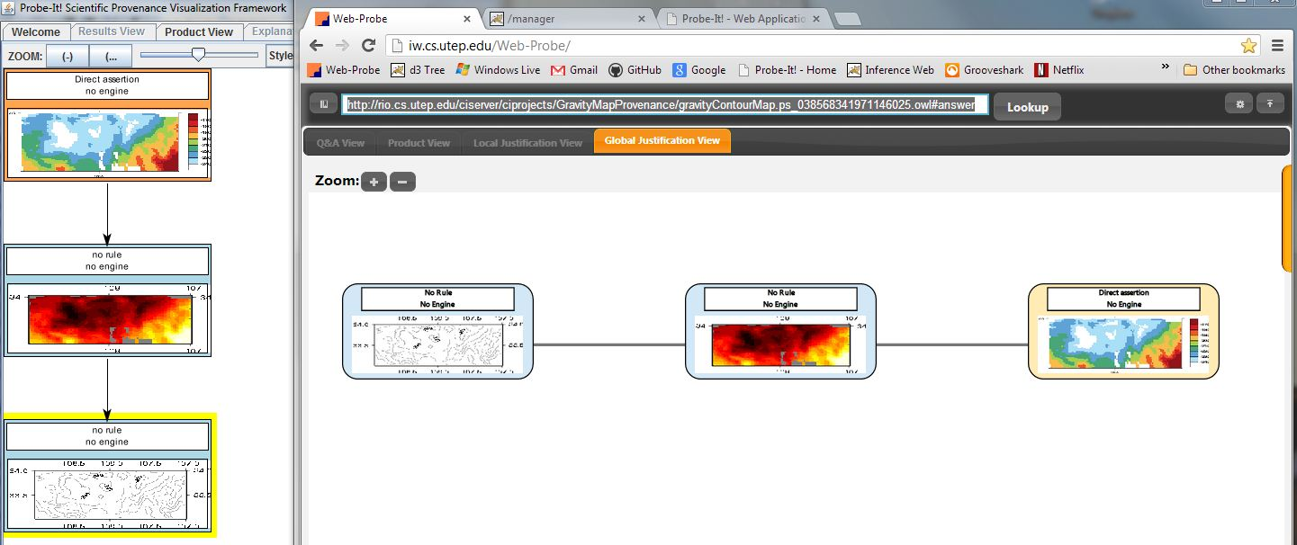
Figure 13: Gravity Map Visualization Comparisons

Web-Probe vs. Probe-It Running Times
One of Web-Probe’s main claims is that the web environment will make the tool more accessible, meaning it will be easier and faster to start the application and begin browsing PML information/proofs. This section serves to show the results of running times for starting the application and loading PML proofs in both applications.

Application Startup Times
The application startup times were generated by timing how long each application took to load the home screen of each tool when starting each application from the Probe-It website (http://trust.utep.edu/probeit/applet/), which has a link to both the Probe-It download and the Web-Probe application. There are two Probe-It startup scenarios that were tested. The first is a startup that assumes the user has the correct Java Runtime Environment (JRE) installed, and thus needs only to download the Probe-It Webstart and start the application. The second startup scenario includes the JRE download and install runtime plus the time it takes to download, install, and run Probe-It. For both Probe-It scenarios there are a sequence of question prompts to install and run Probe-It, and in order to get the best possible run-time results these prompts were accepted/closed as fast as possible to continue with the installation or startup process. In reality most users would probably take some time to read some of these instructions/warnings, and thus would probably take longer to start the application, however for these timing tests are meant to gather information about the fastest run-time scenarios and thus don't take into consideration what the user might do with the user prompts. For Web-Probe, the startup times were tested by simply clicking on the link provided on the Probe-It website, and as is seen below is very quick to startup.
The results for the run-time startup tests are found in the graph below (Figure 14). The results show that the Web-Probe application has much faster startup times. The Web-Probe application takes an average of 0.49 seconds while the fastest possible scenario for Probe-It takes an average of 24.79 seconds. This is with the assumption that the Probe-It startup user trusts the application and speedily goes through the setup and security prompts to get the application started as fast as possible.

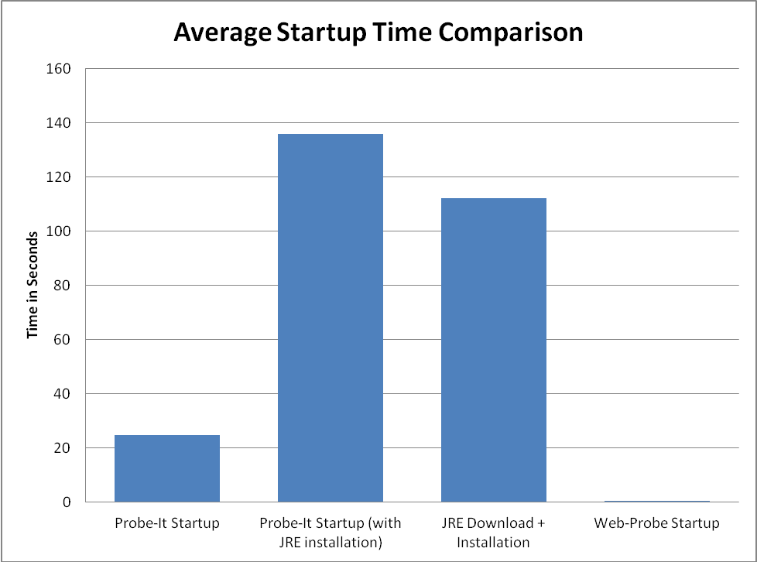
Figure 14: Average Startup Time Comparison Graph

Proof Loading Times
The next set of test results show the loading times to display the provenance trace graph (called a proof) in the global justification view. The loading time is started from when a user clicks the lookup button to begin the request, and stops the instant the graph/proof is displayed on the screen. These tests are meant to show that Web-Probe loads and presents the provenance justification proofs faster than Probe-It. To test this, 2 proofs that include scientific visualizations in several Node-Sets of the provenance trace were used. The first proof which records a Hole’s Code Provenance trace (http://rio.cs.utep.edu/ciserver/ciprojects/HolesCodeProvenance/DVelocityModelProduct_01044731520407759.owl#answer) is a large a proof which typically takes the longest to load when compared to other provenance examples hosted at UTEP Cyber-ShARE center. The second proof which records the provenance trace of how a scientific publication was put together (http://rio.cs.utep.edu/ciserver/ciprojects/ScientificPublication/ipaw-v4.tex_0016939260199497874.owl#answer) is a smaller proof that takes less time to load, but also includes scientific visualizations within the provenance trace, which typically makes it take longer to load when compared to proofs that only include text.

The above mentioned proofs were tested on three different computers, in order to assess the different loading times and analyze the results. The three computers were chosen based on their overall computation power and locality (proximity to the IW server located at UTEP Cyber-ShARE center where Web-Probe is currently hosted). The computation power and locality both have interesting effect on the resulting loading time of the proofs, which further helps paint an overall picture of how Web-Probe improves upon Probe-It.

Work Station Loads
The work station is a personal computer with 2.8GHz dual processor, located at the Cyber-ShARE center. This computer is relatively close in computing power with that of the computer in section 5.2.3.2.3., and is the only one that showed Probe-It as being faster in one of the loading times for one of the proofs. The main aspect of this computer to keep in mind is the proximity to servers and data resources that are used in the tested examples, which are stored in the Cyber-ShARE center located one room away.

Proof 1
In the results for the first proof (show below in Figure 15), we can see the results are unfavorable for Web-Probe. Probe-It has a better average loading time for the first proof. The difference is an average of less than 2 seconds faster, which is not a very long time but is none the less a a negative result for Web-Probe. These are unfortunate results, but are the only negative results that came out of these set of tests. These results also give the development team information on what is happening in the background and what can be done to improve loading times.
The reason behind this negative outcome can be seen after closer inspection and comparison with the other test results. All the other test results show Web-Probe as having faster loading times, and proof 2 on this same computer also shows Web-Probe as being faster. The reason proof 1 and proof 2 have different results on the same computer is attributed to the structure of the proof. Proof 1 has multiple references to the same node-sets causing the information to be duplicated for every reference in Web-Probe because it uses a Tree-style graph to display the provenance trace. However, Probe-It's default graph style is a Directed Acyclic Graph (DAG) which does not produce duplicates. In this way Probe-It saves time by not producing duplicate information, and thus is able to beat Web-Probe's loading time by almost two seconds on average. We will see in the results that follow that this is the only advantage Probe-It has, and will no longer have once Web-Probe replicates this graph style as well.

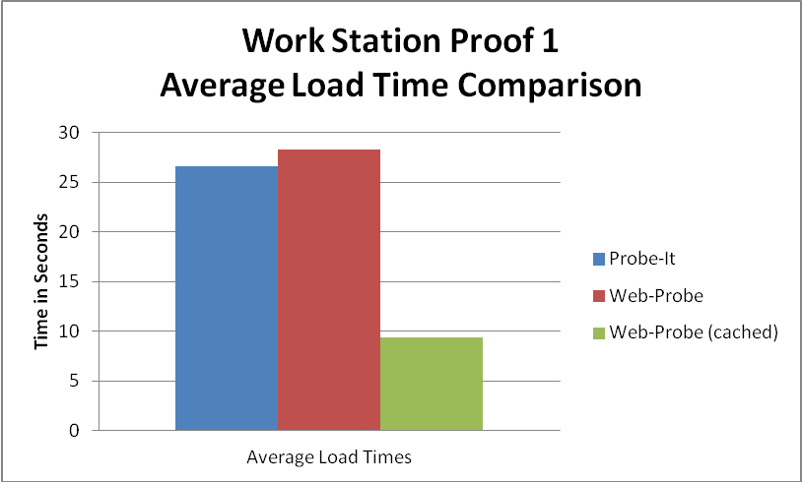
Figure 15: Average Load Time Comparisons for Proof 1 loaded using the Work Station Computer

Proof 2
The results for the second proof come out positive for Web-Probe on this computer. Web-Probe on average is over six seconds faster. In comparison with proof 1, on this computer, proof 2 does better with Web-Probe, because the provenance trace does not include any repeated node-sets.

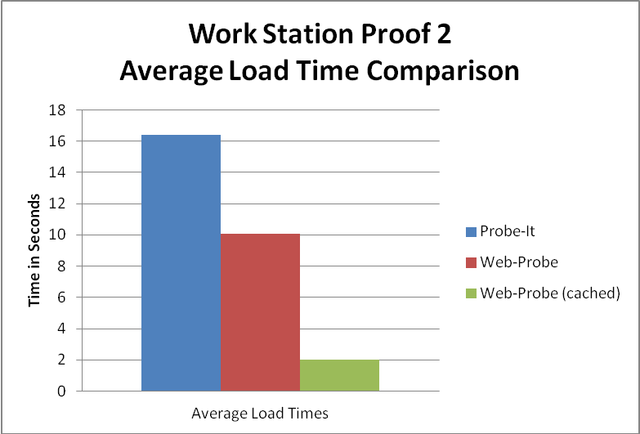
Figure 16: Average Load Time Comparisons for Proof 2 loaded using the Work Station Computer

NetBook Loads
The next set of tests were performed on a Asus Eee PC Netbook, connected to the UTEP wireless network from the Cyber-ShARE Center (same location as the work station computer). The netbook's specifications are much lower than the other two computers in these tests, so longer loading times are expected in these tests. This computer was chosen to compare Probe-It and Web-Probe's performance on a slower machine.

Proof 1
In the first proof the results come out positive as opposed to the same proof on the work station machine. These results show how much Probe-It relies on the local machine's processing power to come out with fast loaded proofs. The first proof takes almost 20 seconds longer to load on the netbook computer, a 70.21% increase in time over the work station computer. In Web-Probe, this proof takes an average of 30.4 seconds, which is only a little over 2 seconds slower than the work station (a 7.46% increase over the work station results). Probe-It is slower and less consistent in loading times, because of its dependency on the local machine, while Web-Probe shows a small increase in loading times, because it depends less on the local computer and more on the server.

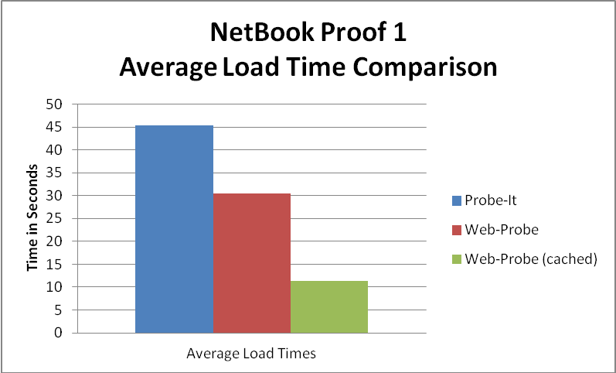
Figure 17: Average Load Time Comparisons for Proof 1 loaded using the NetBook Computer connected to the Cyber-Share Network

Proof 2
The second proof has similar positive results. Probe-It has an increased average loading time from 16.4 seconds to 24.04 seconds, an increase of 46.59%, while Web-Probe's average loading time goes from 10.06 seconds (on the work station) to 12.06 seconds, an increase 19.88%. Web-Probe's loading times are once again faster and more consistent across environments.

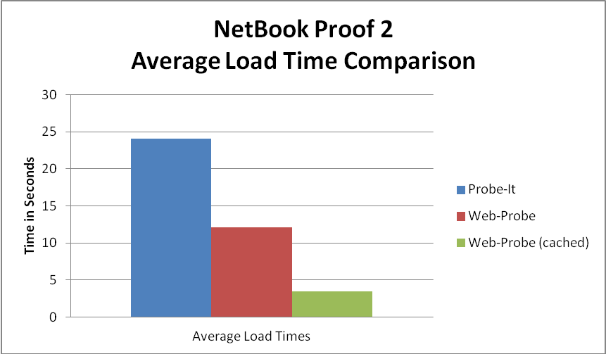
Figure 18: Average Load Time Comparisons for Proof 2 loaded using the NetBook Computer connected to the Cyber-Share Network

Home Desktop Loads
The last set of tests were performed on a 2.8GHz dual-core Desktop Computer located in El Paso off-site of the Cyber-ShARE center. The specifications are comparable to the work station computer, so the processing power does not make a considerable amount of difference in this case (compared to the work station). This computer was chosen to compare Probe-It and Web-Probe's performance on a computer off-site and further away from the Cyber-ShARE center servers. This is where the performance gap between the tools becomes much more apparent.

Proof 1
The first proof shows a huge difference in average loading times between the two tools. Probe-It has a big increase from 26.62 seconds to 13 minutes and 55.8 seconds, an increase of 3139.74%. While Web-Probe increases a mere 4 seconds over the work station times, an increase of 14.17%. This scenario is where Probe-It begins to have very high loading times and Web-Probe really shows its strength and consistency between computers.

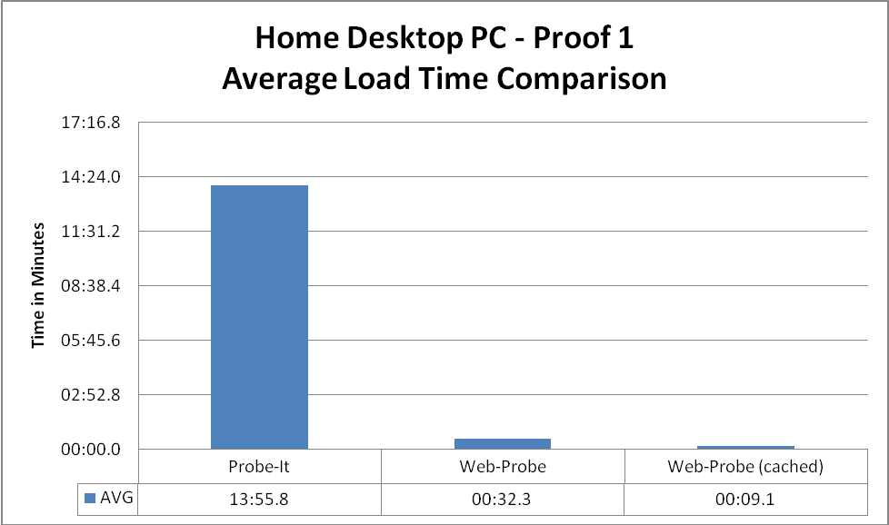
Figure 19: Average Load Time Comparisons for Proof 2 loaded using the Home Desktop Computer

Proof 2
On the second proof a very similar pattern can be seen. Probe-It's average time spikes up to a 7 minutes and 24.6 seconds loading time; compared to an original time of 16.4 seconds on the work station, an increase of 2710.98%. While Web-Probe's average time goes from 10.06 seconds to 10.8 seconds, a 7.36% increase. A difference of 7 minutes and 13.8 seconds between the Probe-It loading time and the Web-Probe loading time on the same proof is a very significant amount of time.

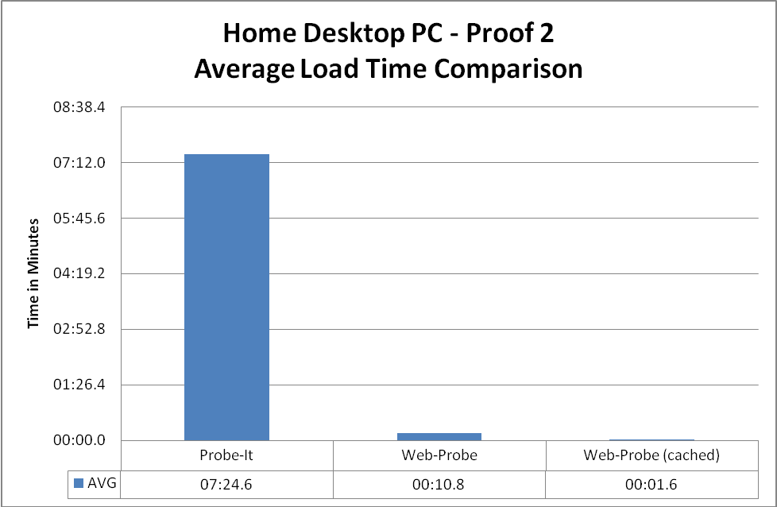
Figure 20: Average Load Time Comparisons for Proof 2 loaded using the Home Desktop Computer

Analysis Conclusions
Overall Web-Probe is able to show in the worst of cases it's on par with Probe-It and in its best case scenario it completely surpasses the loading times of Probe-It. Even its worst case scenario can be improved by the implementation of a Directed Acyclic Graph (DAG) style view, like the one Probe-It uses. With this addition Web-Probe becomes the obvious choice for faster loading times for visualizing provenance traces.

Summary

Conclusion
The Provenance Visualization on the Web project has produced a web-application which in many ways has improved upon its predecessor. The application can be accessed quickly and provides the tools for users to browse provenance which made Probe-It a success. With overall faster running times and easier access, users both new and old can begin visualizing provenance from the UTEP Cyber-ShARE installation or install a local version from the provided instructions.

Future Work
The Web-Probe application still has much more room to grow. Some of the planned expansions to the project are included in the following list:
- Support for PROV-O compliant provenance (PROV-O is a new W3C recommendation for provenance representation).
- Support for PML 3.0, which is the new version of PML currently being developed.
- Addition of more Justification View graph styles, such as the DAG (Directed Acyclic Graph) style supported by Probe-It.
- Among other additions to the user interface to improve user experience

Issues List
The Web-Probe application is still experiencing some issues, and a current list of them can be found below, while a more frequently up-dated list can be found at the Web-Probe github site (https://github.com/hdporras/Web-Probe/issues) along with detailed information and discussions.

Issues List:
- Currently selected tree node not has no bounding box
- SVG text in nodes not displayed with correct new lines
- "Fisheye" display not working correctly in Global View
- Display default images for non-text/non-image conclusions
- Currently selected node should be displayed across views
- Possible addition of Local View in Global View
- DAG view not yet being displayed
- Some PML not showing Used to Infer section correctly
- Look into Null rules and engines
- display current node-set URI
- Display direction arrows in Global View
- Change Engine and Rule Provenance Popups
- Change indentation of text (KIF) in Global Viewer

References
[1] Paulo Pinheiro da Silva, Deborah L. McGuinness, and Richard Fikes. A Proof Markup Language for Semantic Web Services. Information Systems, 31(4-5):381{395, 2006.

[2] Inference Web: PML Documentation. Documentation. http://inference-web.org/wiki/Documentation.

[3] Deborah L. McGuinness and Paulo Pinheiro da Silva. Infrastructure for Web Explanations. In D. Fensel, K. Sycara, and J. Mylopoulos, editors, Proceedings of 2nd International Semantic Web Conference (ISWC2003), LNCS-2870, pages 113{129, Sanibel, FL, USA, October 2003. Springer.

[4] Inference Web. Main Page. http://inference-web.org/wiki/Main_Page.

[5] Deborah L. McGuinness and Frank van Harmelen. OWL Web Ontology Language Overview. Technical report, World Wide Web Consortium (W3C), February 10 2004. Recommendation.

[6] Inference Web: IW-Browser. http://browser.inference-web.org/iwbrowser/.

[7] Probe-It! Home. http://trust.utep.edu/probeit/.

[8] VisKo: Open Suorce Visualization Knowledge. http://openvisko.org/.

[9] D3: Data-Driven Documents. http://d3js.org/.

[10] Web-Probe. Provenance Visulaization on the Web. http://iw.cs.utep.edu/Web-Probe/.

[11] Visualization Cache. http://trust.utep.edu/probeit/cache/.

[12] PML-SPARQL-Services: Web Services. http://trust.utep.edu:8080/provenance2/.

[13] JQuery: Write less, do more. http://jquery.com/.

[14] JQuery: User Interface. http://jqueryui.com/.

[15] Introducing JSON. JSON (JavaScript Object Notation). http://www.json.org/.

[16] JQuery BlockUI Plugin. http://www.malsup.com/jquery/block/.

[17] qTip: JQuery Plugin. http://craigsworks.com/projects/qtip/.

[18] Direct Web Remoting. DWR - Easy Ajax for JAVA. http://directwebremoting.org/dwr/index.html.

[19] git --fast-version-control. http://git-scm.com/.

[20] github. Build software better, together. https://github.com/.

